Indbiz Website Bugs:

1. Title – needs to be fixed to Indbiz|About or Indbiz|Blog – helps in navigation

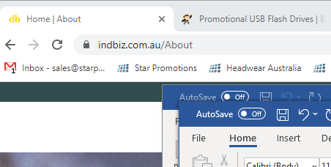 

1. Need to search only for local businesses using the right GPS Location (google location APIs)

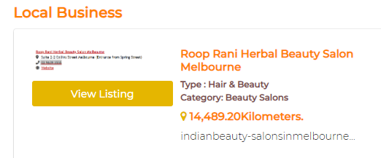

1. Social media links in **header** and **footer** do not redirect to target pages

Facebook, twitter, LinkedIn, Instagram

1. Need to accept at least 8 digit phone number

